Billing & Consignment Architecture
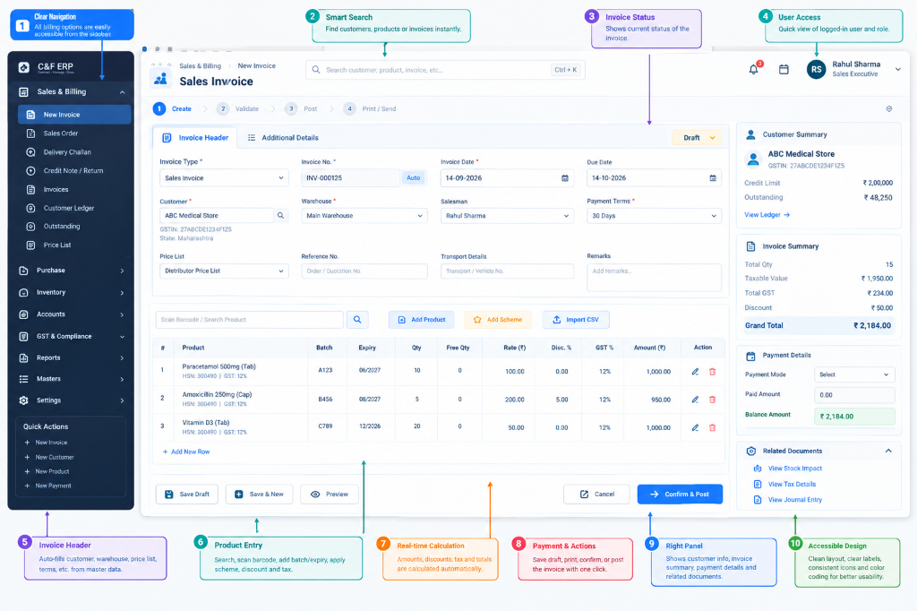
UI Reference: Sales Invoice Dashboard Layout
=== USER'S ORIGINAL PROMPT (CONTEXT) ===

Yes. **This should definitely be part of the billing architecture of your C&F ERP.** In fact, for your type of business, I would make **Cargo / Consignment & Freight Management a dedicated section inside the billing workflow**, rather than treating freight as just another miscellaneous charge.

The important idea is that one invoice/dispatch can contain:

* Cargo/consignment information
* Transporter information
* Freight calculation
* Loading/unloading
* Other logistics expenses
* Charges recovered from customer/principal
* Actual expenses paid
* Profit/margin on the consignment
* Accounting entries
* Stock/dispatch information

And the ERP should calculate the relevant totals automatically.

---

1. Updated Billing Architecture

Previously we had:

Customer
↓
Sales Order
↓
Sales Invoice
↓
Tax + Stock + Accounting
↓
Reports

For your C&F ERP, I would expand it to:

BILLING / DISPATCH
│
┌──────────────────┼──────────────────┐
↓ ↓ ↓
SALES ORDER DIRECT BILL RETURN
│ │
└──────────────────┼──────────────────┘
↓
INVOICE ENGINE
│
┌──────────────────┼───────────────────┐
↓ ↓ ↓
CARGO DETAILS PRICING/TAX LOGISTICS
│ │ │
↓ ↓ ↓
Consignment Discounts Freight
Packages GST Transport
Weight Loading
Volume Unloading
LR/GR Other Expense
Vehicle
│ │ │
└──────────────────┼───────────────────┘
↓
COST CALCULATION ENGINE
│
┌──────────┴──────────┐
↓ ↓
CUSTOMER/PRINCIPAL ACTUAL COST
CHARGES EXPENSE
│ │
└──────────┬──────────┘
↓
BILLING TOTAL
│
↓
POSTING ENGINE
│
┌──────────────────┼──────────────────┐
↓ ↓ ↓
INVENTORY ACCOUNTING GST
│ │ │
↓ ↓ ↓
Stock Ledger General Ledger Tax Records
│
┌──────────────────┼──────────────────┐
↓ ↓ ↓
Customer Ledger Expense Ledger Profitability
│
↓
Outstanding

This is much closer to what I would recommend for your ERP.

---

2. Add a dedicated "Cargo & Consignment" section

On your invoice screen:

Sales Invoice
│
├── Invoice Header
├── Products
├── Additional Details
│
└── Cargo & Consignment

But I would actually make **Cargo & Consignment** prominent enough that users can access it without digging through 10 menus.

For example:

┌─────────────────────────────────────────────┐
│ Invoice Header │
│ │
│ Customer Warehouse Salesman │
│ Invoice Date Payment Terms Due Date │
└─────────────────────────────────────────────┘

┌─────────────────────────────────────────────┐
│ Products │
│ │
│ Product | Batch | Qty | Rate | GST | Amount │
└─────────────────────────────────────────────┘

┌─────────────────────────────────────────────┐
│ 🚚 Cargo & Consignment │
│ │
│ Consignment No. LR/GR No. │
│ Transporter Vehicle No. │
│ Packages Gross Weight │
│ Net Weight Freight │
│ │
│ [+ Cargo Details] │
└─────────────────────────────────────────────┘

---

3. What should Cargo Details contain?

I would divide it into **five logical sections**.

A. Consignment Details

CONSIGNMENT DETAILS

Consignment No. [ Auto / Enter ]
LR / GR No. [____________]
LR / GR Date [📅__________]

Dispatch Date [📅__________]

Transport Mode [ Road ▼ ]

Transporter [ ABC Transport ▼ ]

Vehicle No. [ MP28XX1234 ]

Driver Name [____________]
Driver Mobile [____________]

Origin [ Chhindwara ▼ ]
Destination [ Nagpur ▼ ]

---

4. B. Cargo / Package Details

This is particularly useful for C&F operations.

CARGO DETAILS

Package Type Packages Weight
──────────────────────────────────────────
Carton 20 350 KG
Box 10 120 KG
Other 2 30 KG

Total Packages: 32
Gross Weight: 500 KG
Net Weight: 460 KG

You could also allow:

Volume / CBM
Dimensions
Pallet Count
Container No.

when applicable.

---

5. C. Freight Calculation

This is where I would make your ERP substantially smarter.

Instead of simply entering:

Freight = ₹5,000

allow the system to calculate it.

For example:

FREIGHT CALCULATION

Calculation Basis:
[ Weight ▼ ]

Chargeable Weight:
500 KG

Rate:
₹10 / KG

Base Freight:
₹5,000

Loading:
₹500

Unloading:
₹300

Other Charges:
₹200

--------------------------------
Total Logistics Cost:
₹6,000

Or:

Calculation Basis:
[ Package ▼ ]

Packages: 32
Rate: ₹150/package

Freight = ₹4,800

Or:

Calculation Basis:
[ Fixed Amount ▼ ]

Freight = ₹5,000

So the ERP can support different freight models.

---

6. Freight should support multiple calculation methods

I strongly recommend:

Freight Calculation Method

○ Fixed Amount

○ Per KG

○ Per Quintal

○ Per Ton

○ Per Package

○ Per Box

○ Per Kilometer

○ Percentage of Invoice

○ Slab Based

○ Transporter Rate Contract

○ Manual

This becomes extremely powerful.

For example:

0–100 KG ₹12/KG
101–500 KG ₹10/KG
501–1000 KG ₹8/KG
1000+ KG ₹7/KG

The ERP calculates the amount automatically.

---

7. D. Actual Expense vs Customer Charge

This is **very important**.

Don't mix:

> What the transporter charged us

with:

> What we charged the customer/principal.

They are not necessarily the same.

Example:

ACTUAL COST

Transporter Freight ₹5,000
Loading ₹500
Unloading ₹300
Other ₹200
--------------------------------
Actual Cost ₹6,000

But you may recover:

CUSTOMER / PRINCIPAL CHARGE

Freight ₹6,000
Handling ₹500
Other ₹200
--------------------------------
Recovered ₹6,700

Therefore:

Recovery = ₹6,700

Actual Cost = ₹6,000

Logistics Margin = ₹700

Your ERP can automatically calculate this.

---

8. E. Expense Details

I would provide an expense grid:

LOGISTICS EXPENSES

Expense Basis Qty Rate Amount
──────────────────────────────────────────────────────────
Freight Per KG 500 ₹10 ₹5,000
Loading Fixed 1 ₹500 ₹500
Unloading Fixed 1 ₹300 ₹300
Hamali Fixed 1 ₹200 ₹200
Other Fixed 1 ₹100 ₹100
──────────────────────────────────────────────────────────

TOTAL ACTUAL COST ₹6,100

The user shouldn't need to manually calculate the total.

---

9. Then add "Charges to Customer"

Separate this from expenses.

CHARGES TO CUSTOMER

Charge Basis Amount
───────────────────────────────────────────
Freight ₹6,000
Handling ₹500
Loading ₹300
Other ₹200
───────────────────────────────────────────
Total Charges ₹7,000

Now:

Customer Recovery ₹7,000
Actual Cost ₹6,100
───────────────────────────────
Logistics Margin ₹900

This gives management a very useful number.

---

10. Should freight be included in the invoice total?

The system should allow configuration.

For example:

Option A — Freight taxable and billed

Products ₹50,000
Freight ₹5,000
Taxable Value ₹55,000
GST ₹6,600
--------------------------------
Invoice Total ₹61,600

Option B — Freight separately recoverable

Product Invoice ₹50,000
GST ₹6,000
Invoice Total ₹56,000

Freight Recovery ₹5,000

Option C — Freight absorbed by company

Product Value ₹50,000
GST ₹6,000

Customer Total ₹56,000

Actual Freight ₹5,000

So your billing engine should have a setting:

Freight Treatment

[ Included in Invoice ▼ ]

Options:
• Included in product price
• Added to taxable invoice
• Added as separate charge
• Non-recoverable expense
• Principal-recoverable
• Customer-recoverable

The exact tax treatment should be governed by your applicable GST configuration/rules rather than simply by this label.

---

11. Cargo can be connected to the Delivery Challan

This gives you a very clean workflow:

SALES ORDER
↓
PICKING
↓
DELIVERY CHALLAN
↓
CARGO / CONSIGNMENT
↓
DISPATCH
↓
SALES INVOICE
↓
ACCOUNTING

But you should also allow:

DIRECT INVOICE
↓
CARGO DETAILS
↓
DISPATCH

because not every transaction will necessarily require a Sales Order.

---

12. One invoice can potentially have multiple consignments

This is something I'd plan for **now**, even if you don't use it initially.

Example:

Invoice INV-125
₹5,00,000

Consignment 1
LR-1001
Nagpur
500 KG

Consignment 2
LR-1002
Bhopal
300 KG

Consignment 3
LR-1003
Indore
400 KG

Your structure should therefore be:

INVOICE
│
├── Invoice Items
│
├── Consignment 1
│ └── Expenses
│
├── Consignment 2
│ └── Expenses
│
└── Consignment 3
└── Expenses

This is much more scalable than putting one `freight_amount` field directly into the invoice.

---

13. Even better: Cargo should connect to individual products when necessary

For example:

Invoice
│
├── Product A
│ └── Batch A123
│
├── Product B
│ └── Batch B456
│
└── Product C
└── Batch C789

Then:

Consignment
│
├── Product A → 10 boxes
├── Product B → 5 boxes
└── Product C → 20 boxes

This can later help with:

* Cargo reconciliation
* Dispatch reconciliation
* Batch tracking
* Claims
* Shortage/damage
* Principal reporting
* Freight allocation

---

14. Freight allocation

This is another feature I would put into the architecture.

Suppose:

Total Freight = ₹10,000

and the invoice contains:

Product A ₹50,000
Product B ₹30,000
Product C ₹20,000

The system can allocate freight:

By invoice value

Product A ₹5,000
Product B ₹3,000
Product C ₹2,000

or:

By weight

Product A 400 KG
Product B 300 KG
Product C 300 KG

Freight = ₹10,000

A = ₹4,000
B = ₹3,000
C = ₹3,000

or:

Allocation Method:
[ By Weight ▼ ]

Other options:
• By Value
• By Quantity
• By Package
• Equal
• Manual

This is useful for **true product-level profitability/costing**.

---

15. Add a Cargo Profitability panel

I really like this for your ERP.

At the bottom of Cargo Details:

┌─────────────────────────────────────────────┐
│ LOGISTICS PROFITABILITY │
├─────────────────────────────────────────────┤
│ │
│ Customer / Principal Recovery ₹7,000 │
│ Actual Logistics Cost ₹6,100 │
│ │
│ Logistics Margin ₹900 │
│ Margin % 14.75% │
│ │
└─────────────────────────────────────────────┘

This information can be restricted to authorized users.

A salesperson might see:

Freight: ₹7,000

while an administrator/owner can see:

Actual Cost: ₹6,100
Margin: ₹900

That's where your **role-based access system** becomes important.

---

16. Updated Additional Details structure

So I would now change our earlier structure to:

ADDITIONAL DETAILS
│
├── Order & References
│
├── Transport & Delivery
│
├── 🚚 Cargo & Consignment
│ │
│ ├── Consignment Details
│ ├── Package Details
│ ├── Weight / Volume
│ ├── LR / GR
│ ├── Transporter
│ ├── Vehicle
│ ├── Freight Calculation
│ ├── Logistics Expenses
│ ├── Customer / Principal Charges
│ ├── Freight Allocation
│ └── Logistics Profitability
│
├── GST & E-Invoice
│
├── Billing & Shipping Address
│
├── Sales & Commission
│
├── Commercial Details
│
├── Principal / C&F Details
│
├── Internal Control
│
├── Attachments
│
└── Notes

---

17. And the complete ERP billing architecture becomes

This is the version I would now use as the **master architecture** for your project:

┌──────────────────┐
│ CUSTOMER │
└────────┬─────────┘
↓
┌──────────────────┐
│ SALES ORDER │
└────────┬─────────┘
↓
┌──────────────────────────┐
│ BILLING ENGINE │
└────────────┬─────────────┘
│
┌────────────────────┼────────────────────┐
↓ ↓ ↓
PRODUCT/SALES CARGO/LOGISTICS TAX ENGINE
│ │ │
│ ┌─────┼─────┐ │
│ ↓ ↓ ↓ │
│ Consignment Freight Expenses │
│ │ │ │ │
│ └─────┼─────┘ │
│ ↓ │
│ COST ENGINE │
│ │ │
│ ┌─────────┴─────────┐ │
│ ↓ ↓ │
│ Actual Cost Recovery │
│ │ │ │
│ └─────────┬─────────┘ │
│ ↓ │
└────────────────────┼────────────────────┘
↓
┌────────────────────┐
│ INVOICE TOTAL │
└─────────┬──────────┘
↓
┌────────────────────┐
│ POSTING ENGINE │
└─────────┬──────────┘
│
┌──────────────────┼──────────────────┐
↓ ↓ ↓
INVENTORY ACCOUNTING GST
│ │ │
↓ ↓ ↓
Stock Ledger General Ledger Tax Records
│
┌──────────────────┼──────────────────┐
↓ ↓ ↓
Customer Ledger Expense Ledger Cargo Cost Ledger
│ │ │
↓ ↓ ↓
Outstanding P&L / BS Profitability

The key change is making freight, cargo and expenses a proper subsystem of Billing/Dispatch, supporting:
Invoice → Consignment → Transporter → Freight → Expenses → Recovery → Margin → Accounting → Reports.

=== IMPLEMENTATION PLAN / BLUEPRINT (FOR CLAUDE) ===

Cargo & Freight Billing Architecture Specification

Claude, your task is to implement the comprehensive **Cargo/Consignment & Freight Management** subsystem inside the ERP's billing workflow.

Phase 1: Database Updates (backend/models.py)

1. `Consignment` Model (New Table)
Create a new table linked to `Invoice`.
- `id`, `invoice_id` (ForeignKey)
- `consignment_no`, `lr_gr_no`, `lr_gr_date`
- `dispatch_date`, `transport_mode`, `transporter_name`
- `vehicle_no`, `driver_name`, `driver_mobile`
- `origin`, `destination`

2. `PackageDetails` Model (New Table)
Create a table linked to `Consignment`.
- `id`, `consignment_id` (ForeignKey)
- `package_type` (Carton, Box, etc.)
- `package_count`
- `gross_weight`, `net_weight`

3. `LogisticsCost` Model (New Table)
Create a table to track expenses vs recovery, linked to `Invoice`.
- `id`, `invoice_id` (ForeignKey)
- `freight_calc_method` (Weight, Fixed, Per Package, etc.)
- `actual_freight_cost`, `actual_loading_cost`, `actual_unloading_cost`, `actual_other_cost`
- `recovered_freight`, `recovered_handling`, `recovered_other`
- `freight_treatment` (Included in Invoice, Separate Charge, Non-recoverable)

Phase 2: Frontend UI/UX (Invoice Screen)

1. Cargo & Consignment Panel
- Update `SalesBill.tsx` and `PurchaseBill.tsx` to include a prominent **Cargo & Consignment** panel right under the main Invoice Header or in the Additional Details tabs.
- Add fields for Consignment Details, Package Details, and Freight Calculation.

2. Profitability View (Role-Based)
- Add a **Logistics Profitability** summary card that calculates `Logistics Margin = (Total Recovered) - (Total Actual Cost)`.
- Restrict visibility of `actual_cost` and `Logistics Margin` to Admin roles, while Sales roles only see the `Recovered` charges.

Phase 3: Accounting Engine Integration
- Ensure that when the Invoice is finalized, the **Posting Engine** creates distinct Journal Entries for:
- Inventory (Stock deductions)
- Accounts Receivable (Customer Ledger)
- Revenue (Sales)
- Cargo Cost Ledger (Actual freight paid to transporter)
- Tax Records (GST)
- Keep freight expense strictly separate from product revenue in the General Ledger.

